We have heard terms: SCM, Change mgmt., release mgmt.

What is Configuration Management?

What exactly it is?

**CM: Managing your configuration in terms of:**

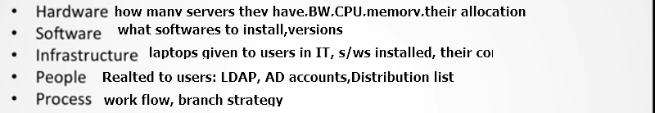

main point is not creating user on 1 server …On 100 server??

Lots of repetition of work

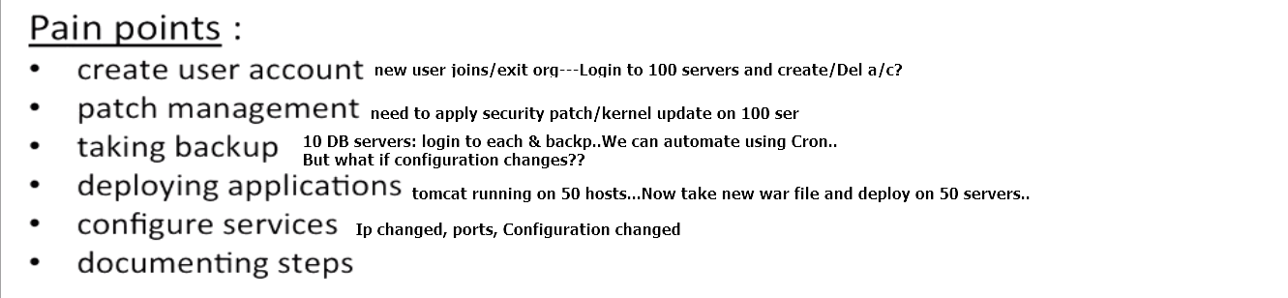



State

At any given point of time, what is snapshot of particular sever/application

Current Ubuntu: 12... Upgraded to14.

What is Chef?

Now, state is 14…State of server changed..

We apply change on 1 server... And it can be populated on all 500 servers synchronously... SOLUTION: Chef

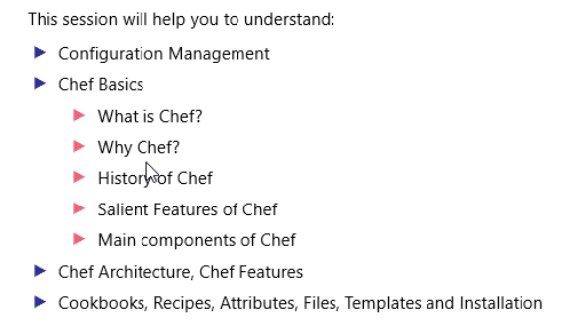

Devops is like Collaboration b/w Dev, Ops, services, product, APP, infra...

Collaboration, sharing, automation, measurement of incentives etc...

Major breakthrough in Infrastructure world: Virtualization

There are different ways infrastructure is looked at.

-:   
Transformed idea of machines as a set of files.

Virtualization is way of **handling machines** **programmatically** (sysadmin)

Collaboration b/w Ops & developers

We can describe Infrastructure as code.. Software defined infrastructure..

[root@devosp1 Downloads]# su vobadm

[vobadm@devosp1 Downloads]$ sudo rpm -ivh '/media/sf_C_DRIVE/Users/vebalusu/Downloads/supermarket-3.0.2-1.el6.x86_64.rpm'

warning: /media/sf_C_DRIVE/Users/vebalusu/Downloads/supermarket-3.0.2-1.el6.x86_64.rpm: Header V4 DSA/SHA1 Signature, key ID 83ef826a: NOKEY

Preparing... ########################################### [100%]

1:supermarket ########################################### [100%]

Thank you for installing Supermarket!

The next step in the process is to run:

supermarket-ctl reconfigure

[vobadm@devosp1 Downloads]$ supermarket-ctl reconfigure

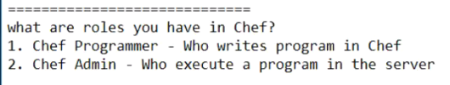

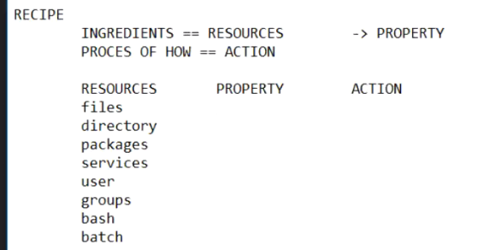

Need of Chef

Sysadmin maintain systems.., it can be 1 machine or be hundreds of machines but the problem is that my job is so boring.

I keep repeating myself isn’t. Like suppose I need to:

* Create a user account
* I need to do patch management
* I need to take the backup suppose you need to take the backup of 100 100 machines every week..

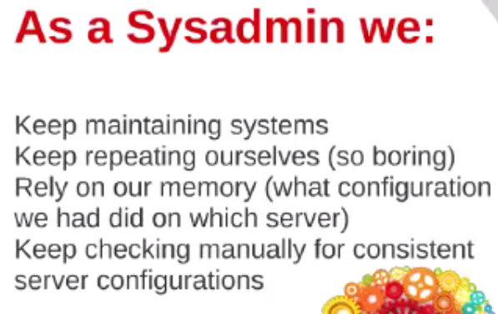

We rely on our memory .. what configuration I had done on server1., what configuration I had done on server2 ..,so we keep on relying on these things of our own memory.

Have to manually check the configurations. Like suppose I have created a user count on server number 8 48.So I need to check go and check manually whether the user still exists after one week or not so that it puts a lot of load on my this brain.

So..,what we want I need chef..

configuration management

What is the configuration management tool: covers set of engineering practices for managing your hardware, software ,infrastructure, people, process .

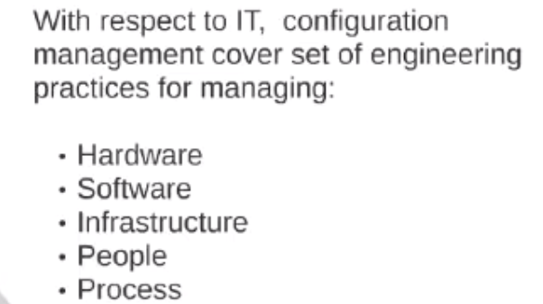

Managing everything without doing it by hands.

Chef

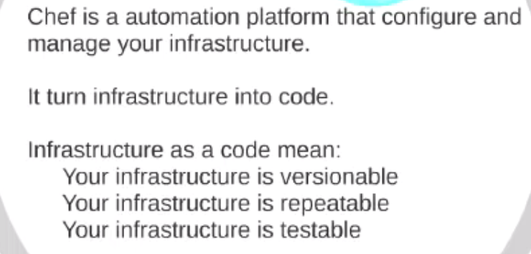

your server is a code.., your switch is a code.., router is a code . So everything can be managed by the code.

* Infrastructure as a code : when you my whole infrastructure is presented to me as a code that means i can create versions ie.., one of the infrastructure, version-2
* infrastructure repeatable ...I need not to repeat the job again
* infrastructure is testable ..so before putting it in the production I might test it whether it is working fine or not if..

What Chef can do

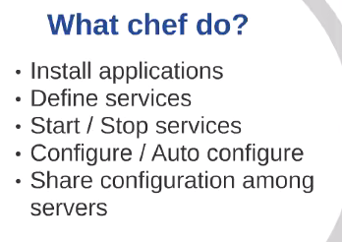

* it can install applications
* define the services for me
* can start and stop the service
* configure or auto-configure the whole applications and the servers

Chef Components

* Used to share the configuration among the different machines.

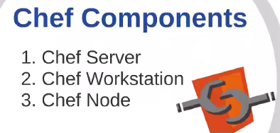

chef node will be that like you my puppet agent.

so chef node is actually the machine where I am going to apply the changes .

The changes will be stored on the server and

I will be working as an admin on the workstation

Chef Primary Components

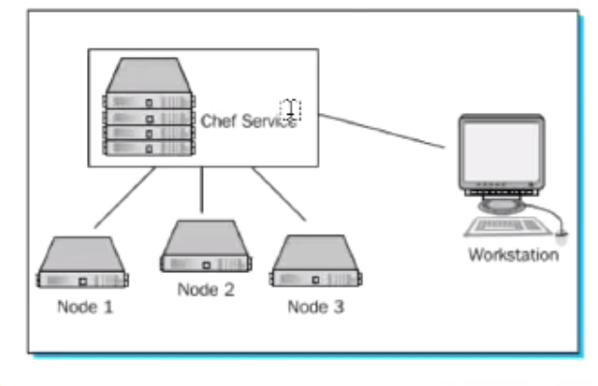chef service/chef server

Nodes which I am going to manage via the chef server

workstation is my machine where I am going to sit and write my code.So being a chef admin being a devop, I will be working here writing my recipes cookbook and whatever code .. i will be uploading it then on the server and the nodes will be using the chef server to get the configuration.

Nodes will never communicate directly with the workstation.

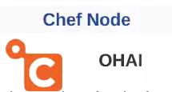

chef node machine plan to managed right.

we have got factor in puppet.., here the package name that takes the configuration of the machine is OHAI .

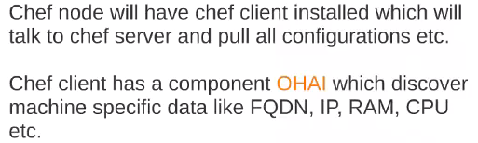

chef node can be a physical virtual or on the cloud.chef node will have the chef client installed.., which will talk to the chef server and pull all the configuration like my puppet agent.

chef client has a component OHAI, which discovers the machine specific data like FQDN, IP, ram cpu..

Chef Server

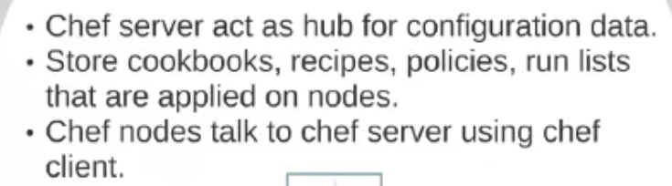

chef server is a central hub for all the Configuration..

whatever being admin I am going to write.. whatever the cookbooks , recipes... whatever is there. It is it will be stored on my chef server.

So chef server act as a hub for the configuration data it stores cookbook recipes policies run list ..,and then these are applied on to the node

chef node talked to the chef server using the chef-client.

chef server is the place which will be storing all the data and the nodes will be communicating with a chef server.



workstation: the machine where I am going to write the code.

he will create recipes, cookbook ,roles ,environments using the chef using the knife tools.

I will write the code there.. I will test the code ..i will upload the recipes, cookbooks to the chef server and then nodes will communicate with the chef server.. nodes cannot directly communicate with the chef's wok station.

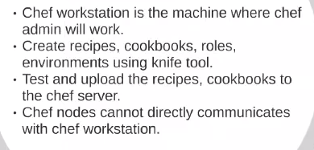

Install Chef Workstation

Start learning🡪 Install Chef Workstation-> later Chef client sever architecture..

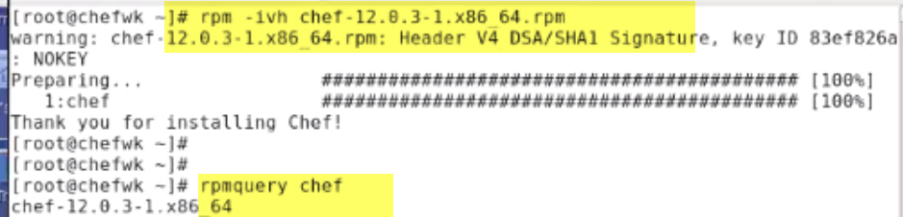

recipe: building block of chef

extension should always be rb and chef uses that domain specific language we call it dsl.

It is built on top of the Ruby programming language to create our recipes.

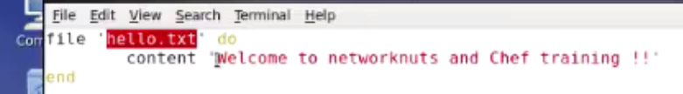

file--> resource and referring to hello.txt

resources are the building block that the chef uses to configure the things on the system

So here the file resource is used to manage a file on the computer.What it takes it takes.., a String as a parameter is specifying the path so here the path are.Because i hadn't specified anything.. so the file will be created in the current directory right and the contents

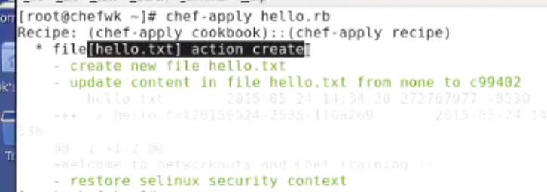

action is create which is the default action a new file is being created

first line : trying to create a file resource and the which is referring to the hello.txt with the absolute path because i hadn't specified the absolute path.So the file will be created in the current directory.

recipe, the cookbooks they are never executed they are always applied.

--- ==> original and

+ ===> new line

file resource title

do statement: denotes the starting of the block so whatever is between do and end will be executed

whatever you want it to be executed for this file resource should be enclosed within that do and the end

attribute: specifying what string what needs to be written in the file

If there is nothing change in the recipe and you try to apply it again it's not going to overwrite.

So it reduces your disk i/o and if it is over the network it really it it saves your bandwidth also.

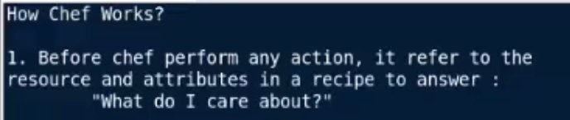

How Chef works

1.) before chef perform any action..t refers to that resource and attributes.

that means resources the file and attribute is the content.

It try and it asked himself what do I care??about means is there something new??

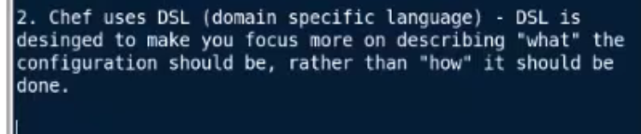

2.)Then Chef decide how to put the machine in the desired state. the main purpose of the dsl.

Before chef perform any action it refer to the resource and attributes in a recipe to answer the question to answer

"what do I care about?"

dsl is designed to make you focus on what you want, rather than how you want ...means the target what target I wish to achieve rather than in scripting where we used to define the each and every steps .

Dsl is designed to make you focus more on describing ,"WHAT" the configuration should be rather than "HOW" it should be done.

So I am more interested in the target, I don't care how you achieve that target right.

first it checks recipe and then it checks the current configuration of the machine then chef decide how to put the system in the desired shape by checking the current state. so if everything is perfect then it does nothing .

If recipe is same and the file is same it says up to date so it does nothing .

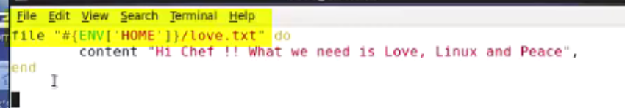

variables are always used with a hash.

I have used double quotes instead of single quotes.., because in chef it doesn't matter if you use single quotes or double quote for string.

But it does matter if you want to evaluate the value of a variable in a string.So i am trying to get the value of the home directory in the string right.

So this hash, environment home is a variable referring to the current users home directory.

so variable references within the strings are always referred with hash.

A string must be enclosed in double quotes when it contains some variable so otherwise single quotes will do no problem because this environment

is carrying the variable so I need to put it in the double quotes .

1. Even, I had executed from /tmp, but the file is going in home dir..,

Single code--> if it is a normal string.

double quotes--> if the string contains a valuable value

1. Modify file wrongly.

chef says that the file should be containing this so if I apply it again it will override the file.

when chef sees that there is a drift the configuration doesn't match is reapplies..

it but if count the configuration matches it does nothing .. it says up-to-date right.

Ex: server number 898 .. somebody had removed or modify the contents of a major configuration file... no problem when the Chef run again ..it will bring them the configuration back to the original. so you your servers will always be in consistent state.



In this video, we see:

Different chef client modes and learning about OHAI.

How it can be used to fetch the nodes information.

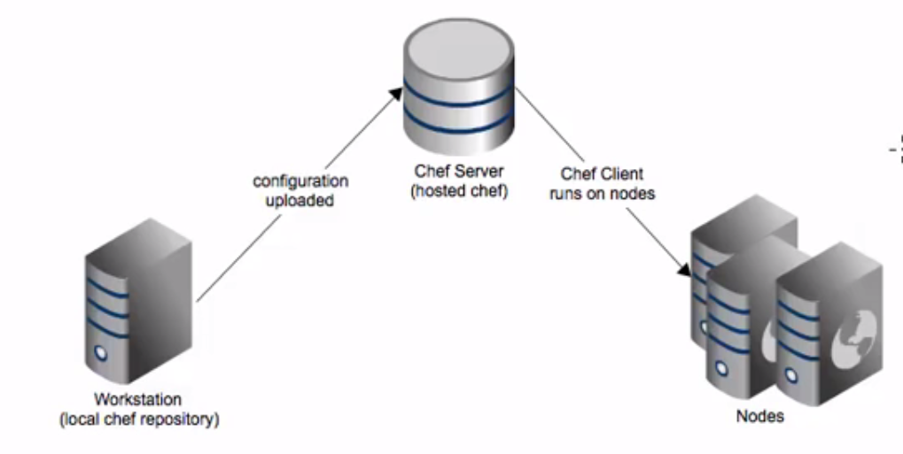

Chef workstation: admin will work and it will upload the configurations on the chef server and then nodes will be actually the machines those are managed by chef and they will be getting the run list or the configuration from the server.

So in any case nodes cannot directly communicate with the workstation.

Chef clients can operates in three nodes.

1. Local mode:

(chef client is working in a local mode, means you have no server no workstation. Just you have installed the chef client on one machine and just learning the things so we call it a local mode.)

I don't have a chef server. i have only the node, the chef client.

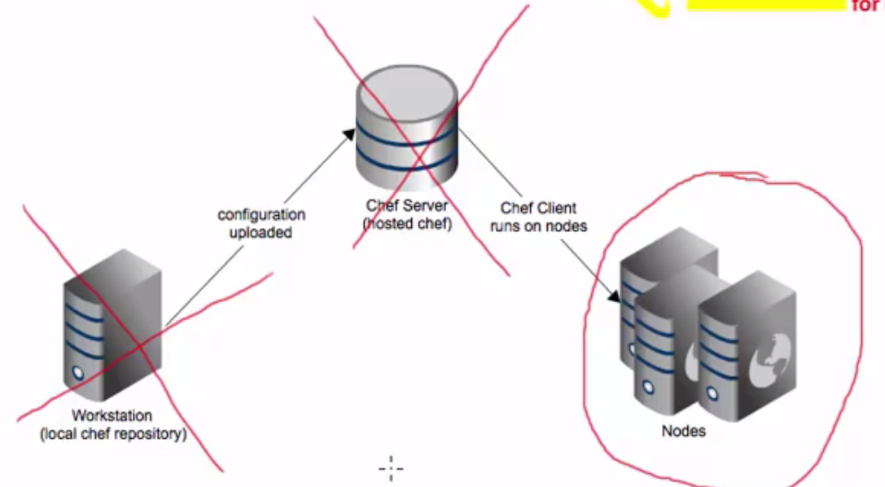

These components does not exist in my network.

So I have only a node, which I am going to use to learn how to write the recipes.., the fundamentals of Chef.

if you have a client which simulates the full chef server, this is called as local mode.

ie.., chef is running in local mode.

So any data that would have been saved on the server is actually written on the node means like:

Suppose you are trying to create a data bag, anything that is actually intended to be stored on the chef server in a production environment is stored locally here because you don't have these machines..

Chef Infrastructure

3. Installing Chef Server, Workstation & Node - Creating & Uploading Chef Cookbooks

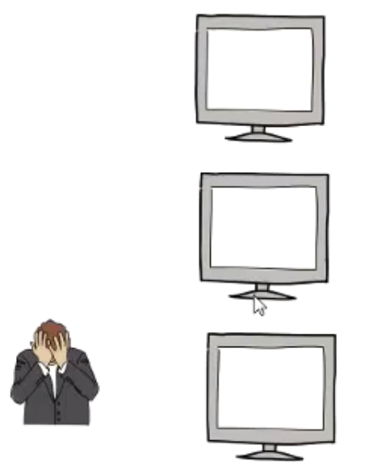

let's assume you have multiple servers:

one machine: apache server , another machine: ftp server and third machine: nfs server

Being admin you have to manually go to each and every machine or you can do SSH to configure these servers.

First you you have to go to the you're a server number one to configure it, then either you have to do SSH.

move to servo number two to configure it.. then again you have to move to server number three or you can do SSH .

It's a real pain it's very difficult to manage as the number of servers will grow.

so what to do so instead of going on each and every machine???

i create a machine which is configured as a chef workstation-->creating chef recipes and cook books on the chef's wok stations --> and then I will introduce one more machine as a chef server. I will upload all the chef recipes and the cookbooks that i have created on the chef's wok stations on to the chef server and then i will configure the servers the actual servers that I intend to manage as chef nodes...

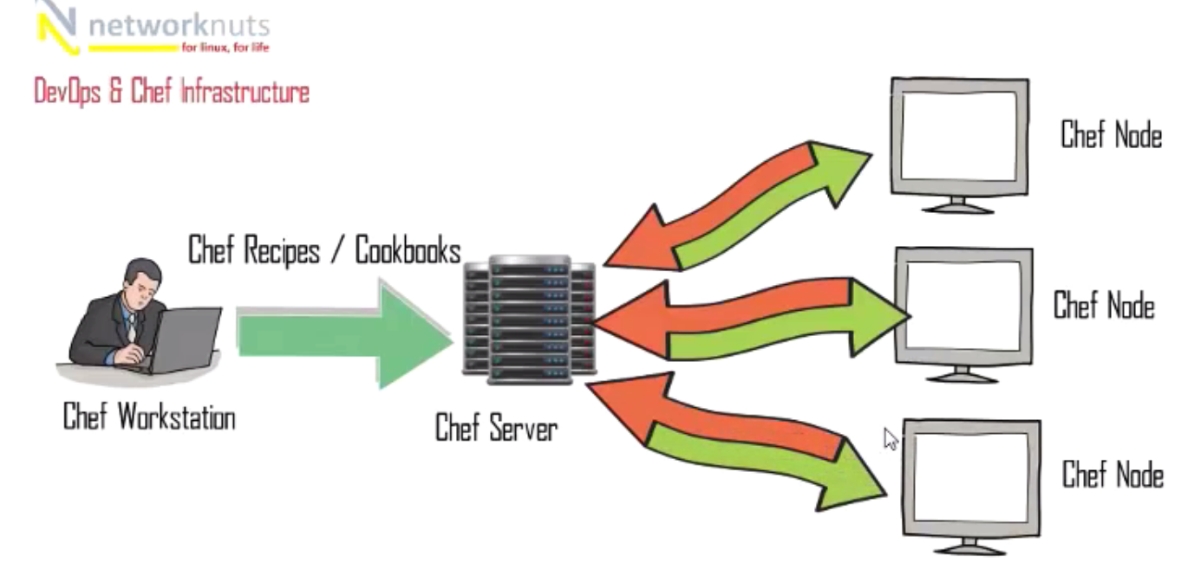

The, I will configure the chef nodes to communicate with my chef server and take the instructions and the recipes from it. So all the nodes will be communicating only with the chef server and they will be taking their configurations from the cookbooks and the recipes that i have created used on the chef work session and then upload it on the chef server.

so this is how the chef infrastructure work ..

Setup CHEF Server

Let’s start configuring the chef server first.

I don't have the dns so i have the host file updated so these are my three machines.

100 will be acting as my chef server 101 will be acting as my chef wok station 102 will be acting as mine chef node.

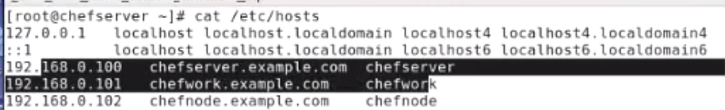

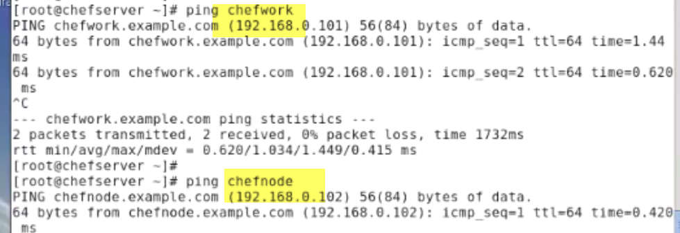

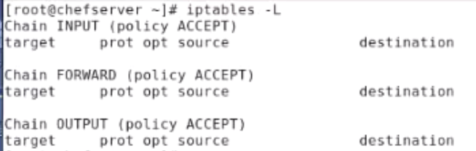

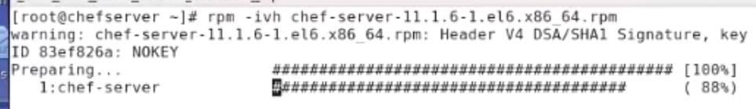

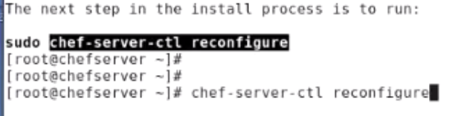

Rpmquery chef-server

Once the package is installed, I need to configure the chef server.

**Chef-server installed properly or not:**

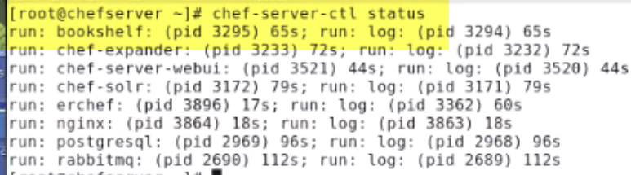





orange background---Chef workstation

Blue machine-->chef server.

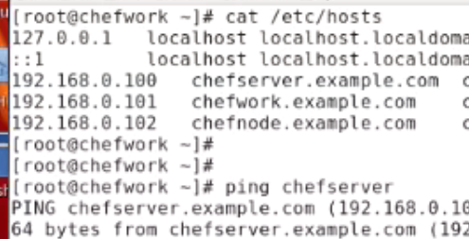

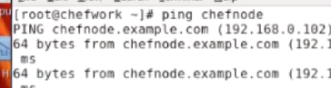

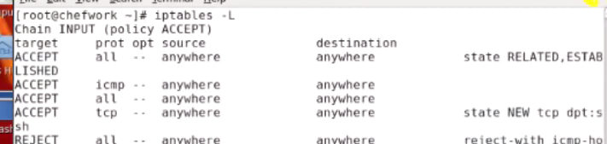

FLUSH IPTABLES

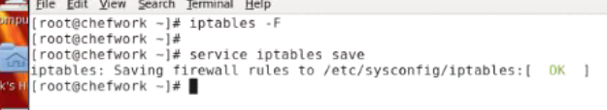

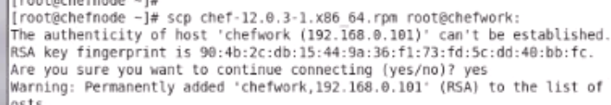

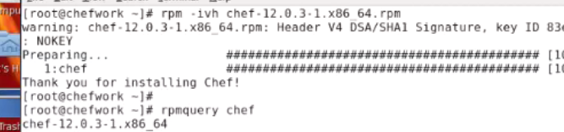

1.) chef is installed

2.)the second step is because the communication between the chef workstation and the chef server should be secure.So we configure our communication based on the certificates,based on the on .pem files.

TODO: copy the certificates from the server to the workstation.

**On chef-server,** goto /etc/chef-server.

three Pam files need to be copied on the chef work session.

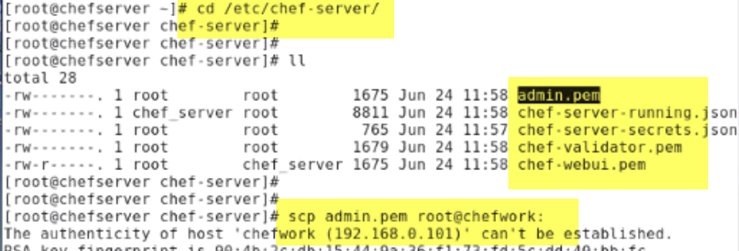

**Workstation:**

create a folder in your home dir .chef..,and copy all the pem files inside it.

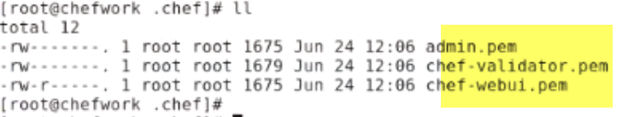

knife configure -i .

Command to configure the knife.., so that workstation will be able to communicate with a chef server.

- Can execute it from inside chef or you can execute it from the home directory.

1.) Where to put configl fiel: the file will be copied

2.) location of your chef server obviously to be https//:chefserver.example.com:443

3.) name of the new user : vobadm

Goto server:

/etc/passwd---> can see user vobadm



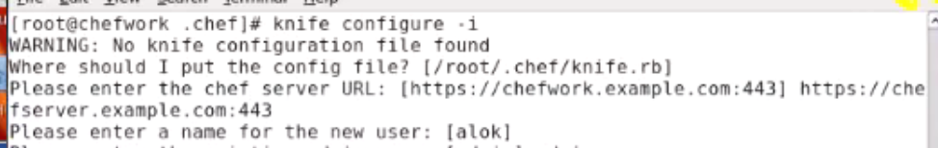

4.) existing is admin

5.) location of the existing admin's private key : admin.pem files location

6.) chef validator clientname: same

7.) now the validator keys: validator.pe location

8.) Chef repo --blank

9.)Creating API user...Enter password : redhat.

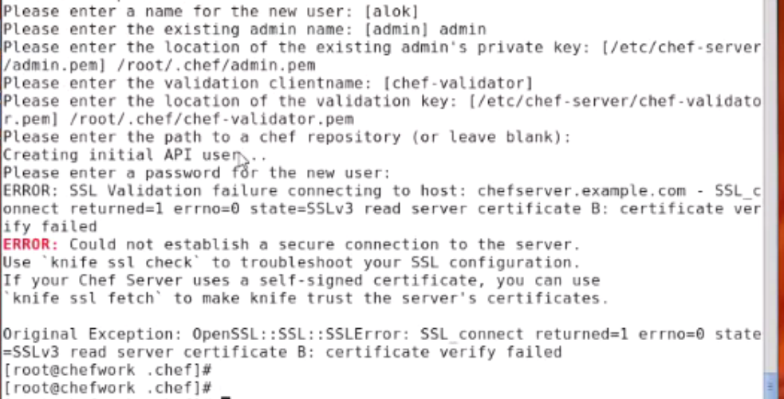

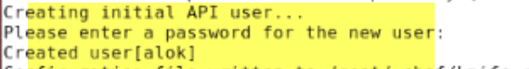

Error:

if it gives an error because the certificate is not yet fetched.. so you can give by giving fetch the certificate.

knife ssl fetch

knife ssl check

Now, the certificates are successfully verified right.

Now I need to give this command again:

knife configure -i ---> error--> overwrite file--> yes.

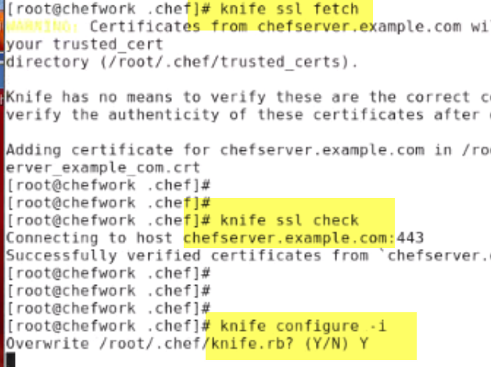

Goto .chef folder .

I only copied 3 pem files..couple of more files chef-webui.pem. and knife.rb

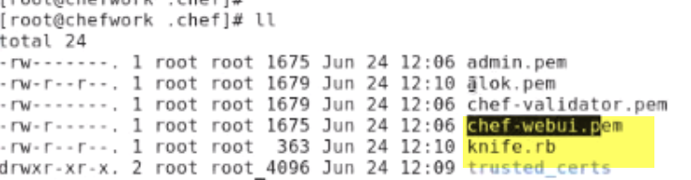

created .Pem file for user and this certificates are inside the trusted_certs

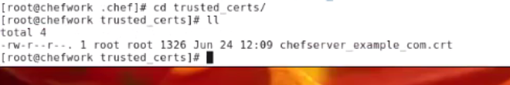

again reconfirm it using,

knife client list

services are running

knife user list

show me the our log and alok

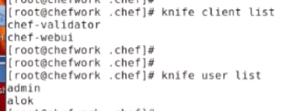



Configure the node and tell the node to communicate with a chef server using the certificates.

black background

flush the iptables

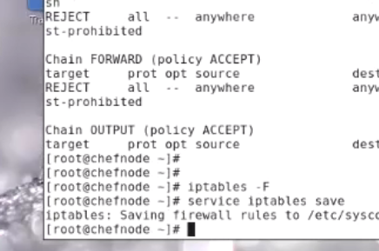

Check my hosts file -->so that the communication should be proper.

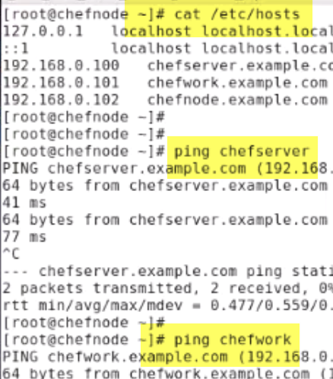

Earlier said,communication is based on the certificate.. secure communication

what I need to do:

Create a directory here .

mkdir /etc/chef

1.)copy the chef-validator.pem from the server inside it.

2.) fetch the certificate from the server

knife ssl fetch -S https://chefserver.example.com -->fetching the certificate from the chef server.

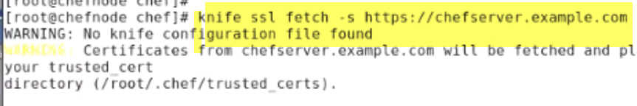

If I move inside my home directory .chef folder.

there's a file, trusted_certs source and this is the certificate copied.. So if you see the time-stamp, the time-stamp is same 12:33 24th of june.

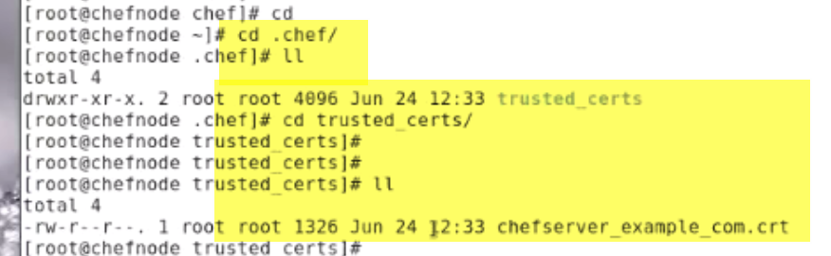

Again use a knife come on knife ssl check -s <https://chefserver.example.com>

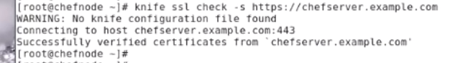

Successfully verified certificates from chefserver.example.com

I need to create a file to have the communication of the node with a server.

cd /etc/chef

creating a file client.rb

log level :info

log location STDOUT

chef server url "https//chefserver.example.com:443"

trusted_certs_dir "/root/.chef/.trusted_certs"

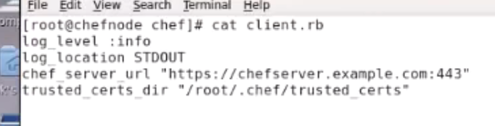

**Join this node to my server.**

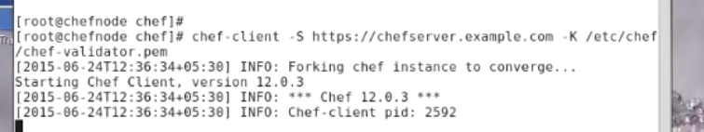

chef-client -S https://chefserver.example.com -K /etc/chef/chef-validator.pem

Join this server using this certificate.

verify: chef knife list

oh oh.., it should be done from the workstation ..Not from the server.

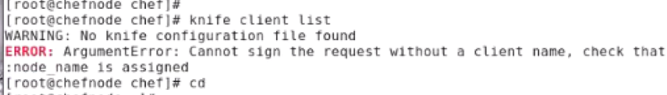

**workstation:**

**knife client list**

**chefnode.example.com**

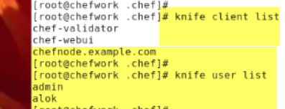

Server:

Open the browser -> https//chefserver.example.com

Accept the certificates.

log on as admin and the password you can see there it's being mentioned in admin and password.

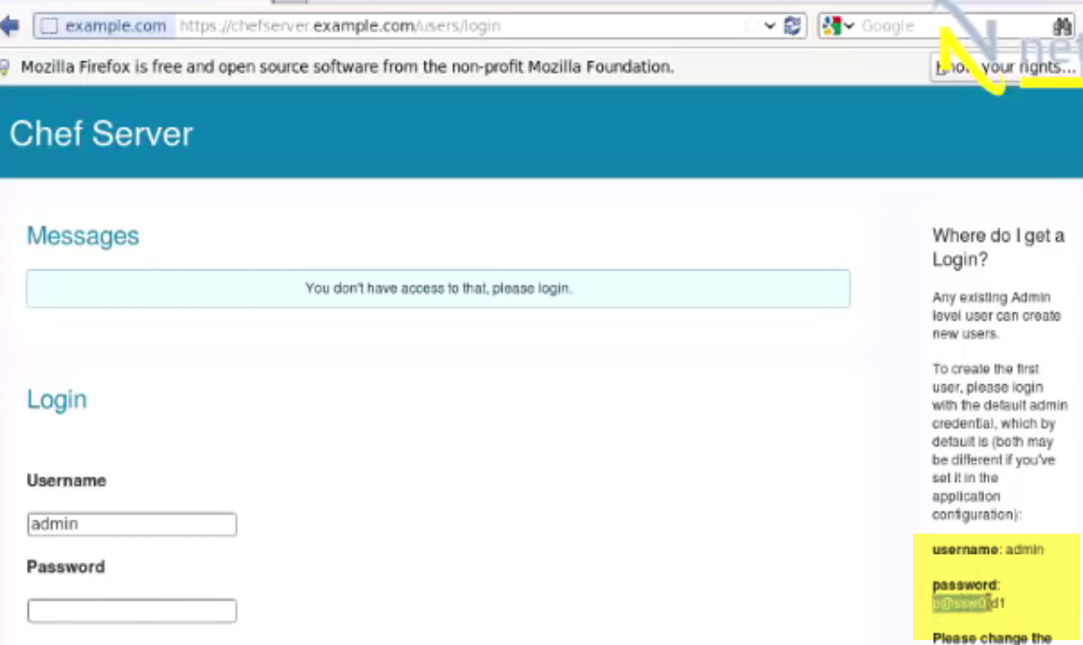

Next: change the password tab

go to the node --->this is your graphical interface

the chef node cookbooks

the node is coming up here that means the node is successfully joined the chef server.

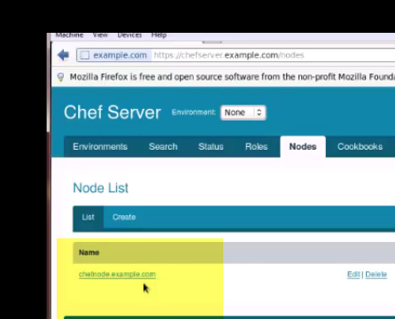

create some cookbooks and recipes and upload it on the server

So this is how my chef infrastructure is completed.

Create a small recipe on the workstation and then upload it.

Workstation:

Cd /var/chef --🡪 No chef directory..

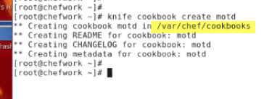

knife cookbook create motd.

I am just trying to create a small cookbook

It goes underwear /var/chef/cookbooks.

if go /var/chef/cookbooks. ,i will have a folder with the name of my cookbook name motd.

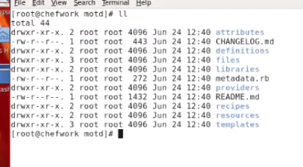

the whole structure is already being created for you by Chef..In puppet we need to created manually.

**create some cookbook and then upload it on the server so that the nodes can use it**

go under the recipes there is a by default file defult.rb

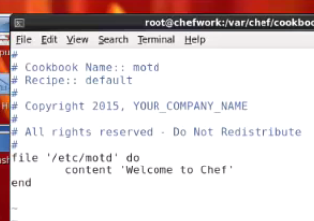

create a file under /etc, the name of motd and.., the content will be welcome to chef.

Before I upload it on the server it's always recommended and beneficial to check for the syntax.

Give the command knife cookbook test motd

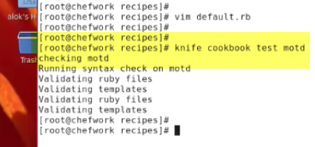

there is no syntax error if there had been any syntax error it would pop up right here.

upload the recipes and cookbooks from the work station to the server:

knife cookbook upload motd

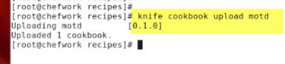

Verify-1

if i go back to the server.., see here earlier if you remember i didn't had any cookbook.

If i click here it is it motd coming up..so you are just created the cookbook on the workstation then uploaded on the server.

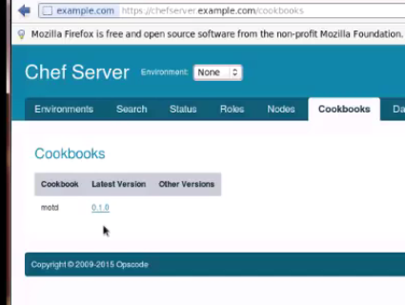

I can use the command line tools

Verify-2

knife cookbook list

this is being uploaded on the server

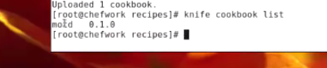

Added cookbook to be applied on my node

Server:

graphical manner->nodes(select chefnode) -->edit--> here recipes are there, but there is no run list.

means this won't be applied here. So just click drag and drop it. I want this cookbook to be applied on chefnode.example.com

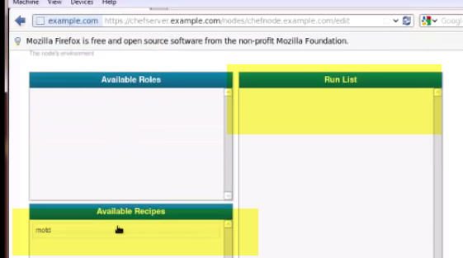

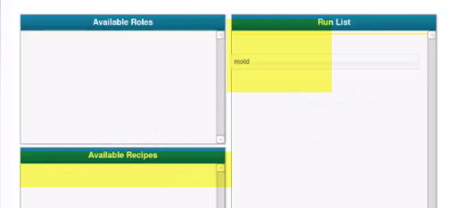

Save it..

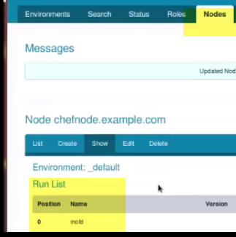

run list… this motd is appearing up here

chef node:

node🡪 cat /etc/motd----> nothing

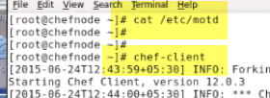

**apply the run list**

**cat /etc/motd -->file is created.**

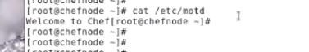

**How to configure one machine as a chef workstation.., another machine as chef server, chef nodes..**

**Creating the recipes and the cookbooks on the workstation.. uploading it on the server and then applying it on the nodes..**



**process of creating a cookbook**

you create the cookbook -->start writing the recipes -->if you are using the templates , add the template--> and in the template adding the attributes -->attributes then you will be updating your metadata, the information about your chef cookbook..

Then the last step will be testing and uploading…

So this is the process of creating the chef cookbook

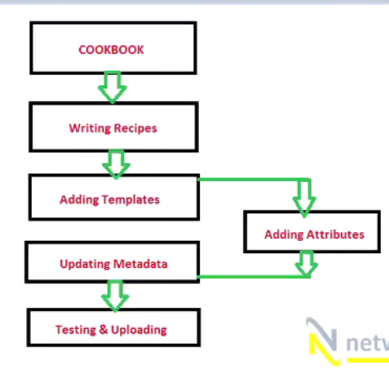

**workstation:**

just for the sake of connectivity--->checking whether i am able to communicate with all the machines or not

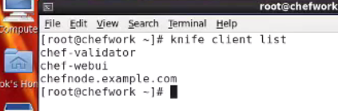

let's create a cookbook here.

Before creating cookbook, lets see: how many cookbooks are available currently on my server

knife cookbook list

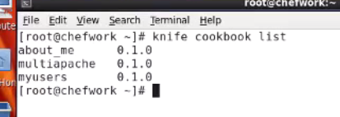

Create a cookbook with the name of apache

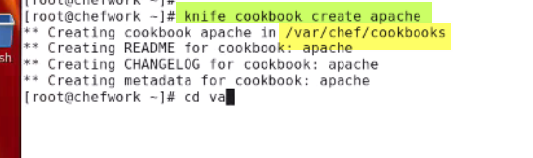

Cd /var/chef/cookbooks

you will find a directory with the name of Apache..it contains the template

first thing :create my recipe

Goto create it under the recipes folder and just modify defaiult.rb

start with installing the package because the package need to be there on the chef node

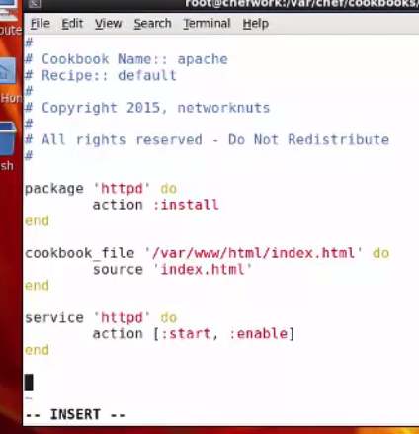

action default install, not required

once the package is installed you need to send some HTML files

default root for the Apache is /var/www/html..

here i will be using cookbook file resource.So give a cookbook_file and the location is the main file

source index.html

so i need to create this files under the files in my chef cookbook.

start service

action will obviously be start , i will also recommend if you do a enable

enable -> it should be available across the reboot (like chkconfig)

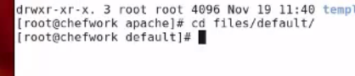

goto files folder .. inside files i have a default folder

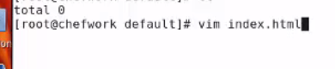

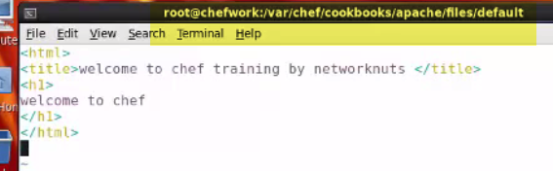

test

before i upload it on the chef server it's always recommended to check it for any syntax error

knife cookbook test apache

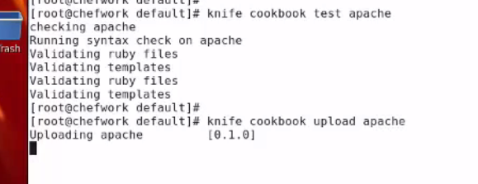

knife cookbook upload Apache

Again give the command:

knife cookbook list--> it should show me my cookbook apache

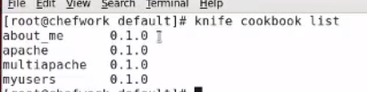

But the cookbook is not added in the run list of the node

Add cookbook which is available on the server into the run list of the nodes

Runlist

1. I can do it graphically
2. knife node runlist -> add the name of the machine chefnode.example.com and the name of the cookbook apache

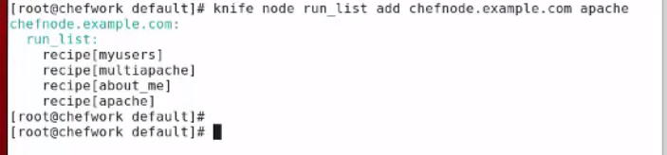

chef client

Run chef-client

it should be able to show me the web server running and the particular HTML page should appear

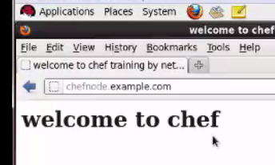

Open the browser http://chefnode.example.com

Welcome to chef

Change it

Change it..let use temple attribute ...

example.., I intend to run apache on port number 81,not 80 which is the default port..

**How to change it using the template**

workstation:

1. goto -> recipes ->default.rb

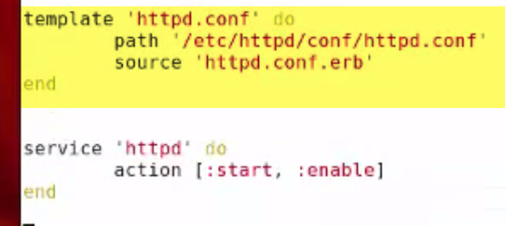

I write a template httpd.conf ..,default location for the file

Where it should be getting the template --->source httpd.conf.erb

Make sure that the extension should be erb (embedded Ruby) .

I now need to create this file (erb) inside the templates folder

This is only thing I added..

For sake of understanding, working properly or not. Change index.html

2.)Files--> default--> index.html--> change h1 to h2

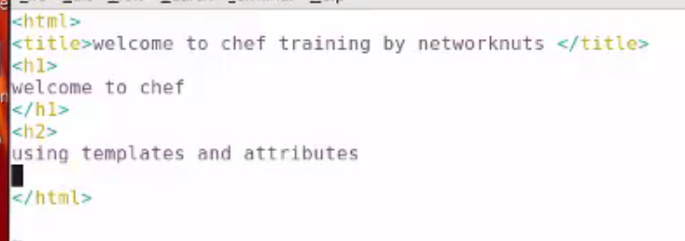

1. I need template file

Goto: templates--> default.

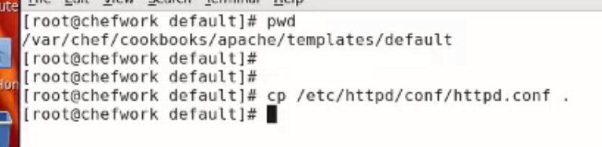

i copy /etc/httpd/conf/httpd.conf .. to current location.

So that i need not to write the complete file once again i'm very lazy on those things okay.

just before this, I need to create the attribute files.. where it is going to take the attributes.

there's a attributes folder

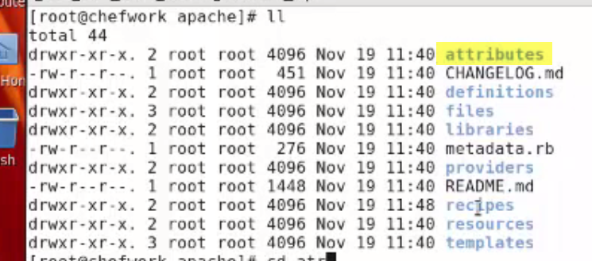

1. goto attributes folder --> I create a file -->default.rb

default attribute..,the name of my cookbook apache

going to change the port.. listen you want to specify .

So, i just created a default attribute.., the name of the cookbook and the name of the attribute name.

So the this is default apache cookbook name and port number 81.

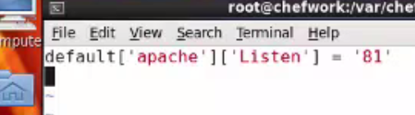

5.) goto -->templates-->default

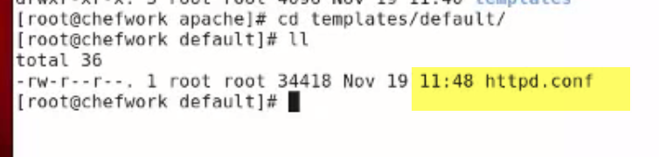

open that httpd.conf file

if you remember, this is the same file I copied.

search for the word listen-->comment that out.And,

here i am writing node specific my Apache and the value to listen

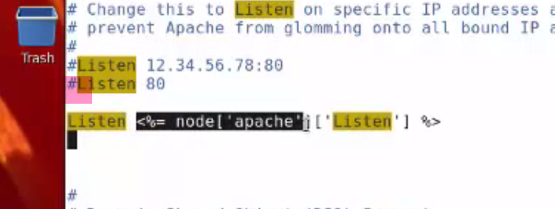

this is going to take the value of attribute, value 81 from my files which I have just created in the attributes folder.

Once the conf file is changed:what you need you need to do is??

restart the service so that the things will be applied.

I prefer restart in my recipe..

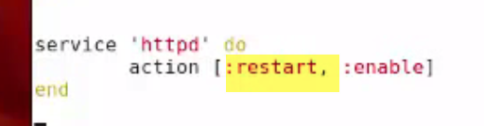

Restart🡪because I had modified index.HTML and also and i have introduced this httpd.conf.erb

One more thing::

I hadn't rename this. Rename to erb..

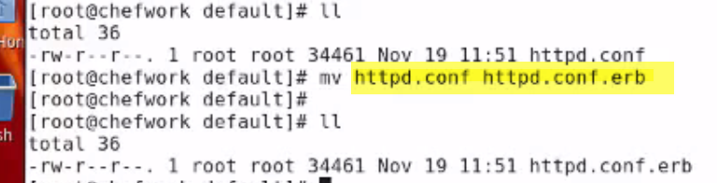

knife cookbook test apache

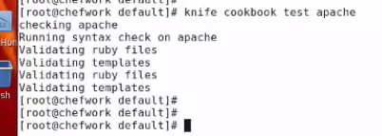

i also need to change metadata.rb, because I had done some changes in my cookbook.

cookbook folder--> metadata.rb

change here say version 1.1

Test once again

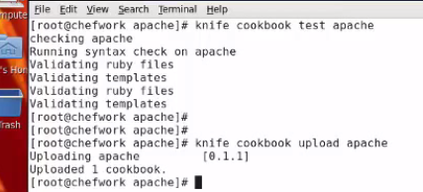

Upload: knife cookbook upload Apache

Add in run list: knife node run list add chefnode.example.com apache

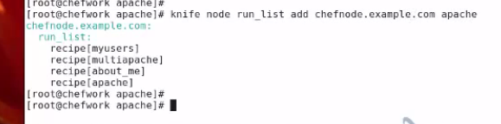

**Node**

chef-client

it should show you that the service is restart.

**Issue**:

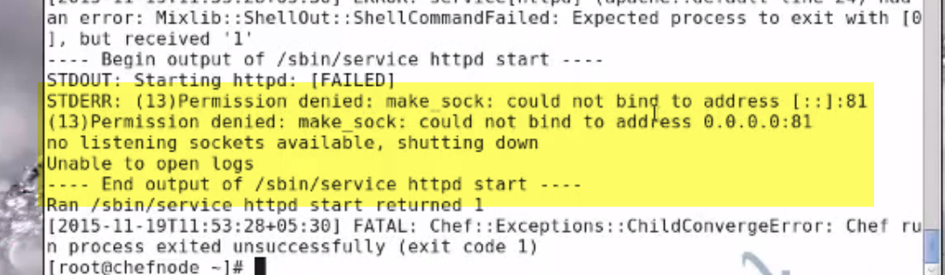

Permission denied it cannot run on port number 81

because of the selinux

sestaus-🡪 running

setenforce permissive

open the browser

chefnode.example.com:81

it's working welcome to chef using templates and attribute

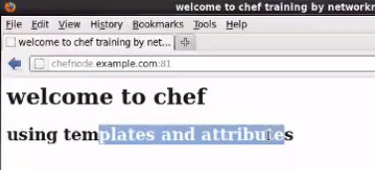

When I upload the cookbook on the server when it actually goes inside the server???

Interesting...you can keep on adding more attributes in httpd.conf file

**chef server:**

When you upload cookbook on the servers, it actually goes inside /var/opt/chef-server.

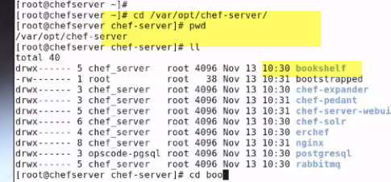

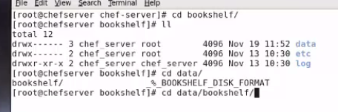

inside this -->you will see a bookshelf.

bookshelf is the service which is responsible for storing all cook books

inside bookshelf--> goto data--> and bookshelf.

Here, you can see a lot of files.. here now it's very difficult to check where is my cookbook.????

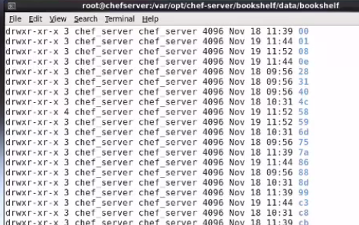

grep any keyword in your cookbook

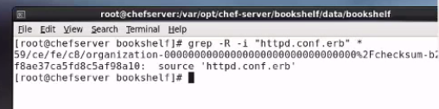

hash-->checksum

copy location--> cat paste it

this is your cookbook.

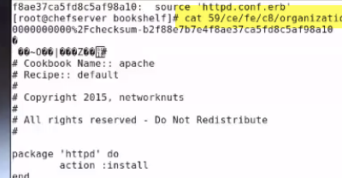

when you upload it on the chef server ,where it goes is?? it goes inside the bookshelf.

and location is: /var/opt/chef-server

5.) Chef Environment

**workstation :** knife node show chefnode.example.com

so i will be able to see the environment in which it is working

the recipes those are applied

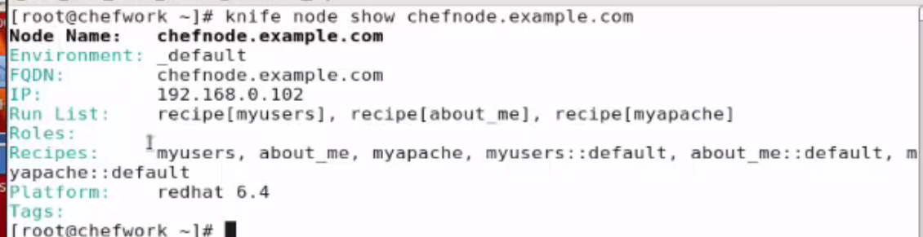

**node:** chef-client

previous video that we had done if I open the browser-->chefnode.exampe.com:81

this is the apache cookbook

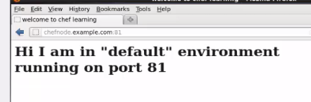

environment is a way of grouping your nodes in a particular manner

like suppose: you have got a testing environment, development environment.

So in testing environment, you want some other configurations and in your development environment or production you you want something else like port number 81.

when I'm in production i would like to run this apache on port number 81 but when on test environment i want to run it in port number 85

So the easiest way of doing this is, create two separate environments.

One environment will be from testing and once i am satisfied with my test environment I can bring the node in the production environment.

So a node can be a part of the test environment or production environment.., but at a time a node can be a part of one env.. only .

By default chef gives me a default environment.

Server:

open the browser--> open my portal--chefserver.example.com

Goto the environments -->you can see a default environment is there and by default all the nodes will be a part of the default environment.

goto env--> click on creates --> give any name --> testing

If you wish, you can also restrict that if you if you've got multiple versions of cookbook available say by: version number number one, two

The cookbooks will be applied in the test environment, and above version number two there will be a part of a different environment.

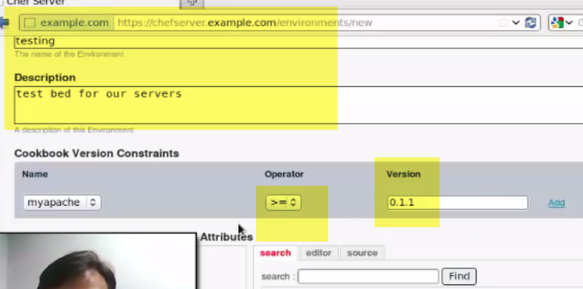

**once the testing environment is there,I can make a node a part of the testing environment .**

this testing environment will include the cookbooks where my Apache version should be greater than or equal to 0.1.1

before I change the node in the testing environment,

**node:**

knife environments -->to see how many environments i have got

i have got a default one coming up here, and the testing one is also coming up there

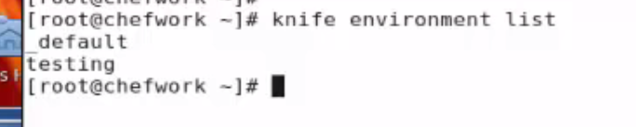

I want to have my configuration in such a manner that:

if this particular node works in the default environment,which is the default one

1.) the patches should run on port number 81

2.) but as I move the node in the testing environment the port of the par-tay will change to something as say 86

**I want that when my machine is in the default environment the Apache should work on port number 81**

When i change the environment to testing, apache should automatically on different ports 85

**What I intend to do???**

Using environment, I want to change the port of the apache without changing directly in the cookbooks.

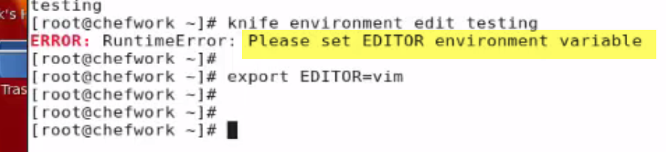

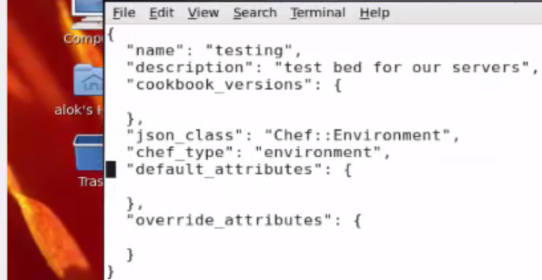

these are the default attributes and these are the override attributes.

So in over override attributes, i will be defining it that if the Machine goes in this testing environment.. these attributes should be overriding any other attribute which is coming from the cookbook.

here comes the name of my cookbook apache.

I want to change the listen right and I change it to say 85.

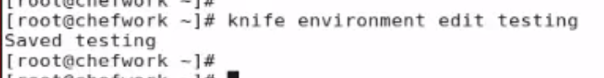

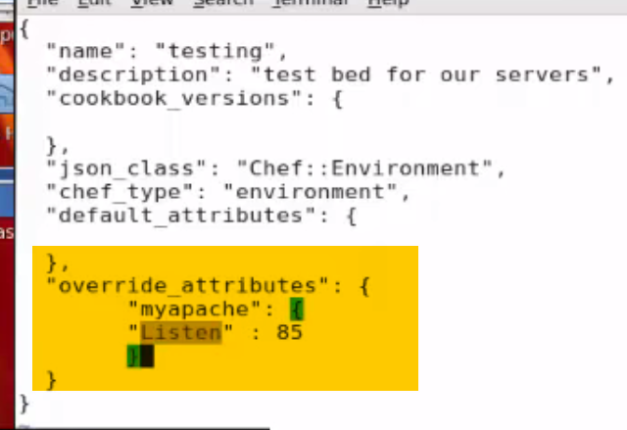

I am just changing a one attribute…you can change a lot of other attributes here.

And I'm not doing it just for the sake of simplicity.

By default my node is in the default environment.., so once it is done, the environment is being set and change some attributes there also.

**Now need to change my node which is in the default environment to the testing environment:**

**server:**

**environment ->testing environment ->click on add**

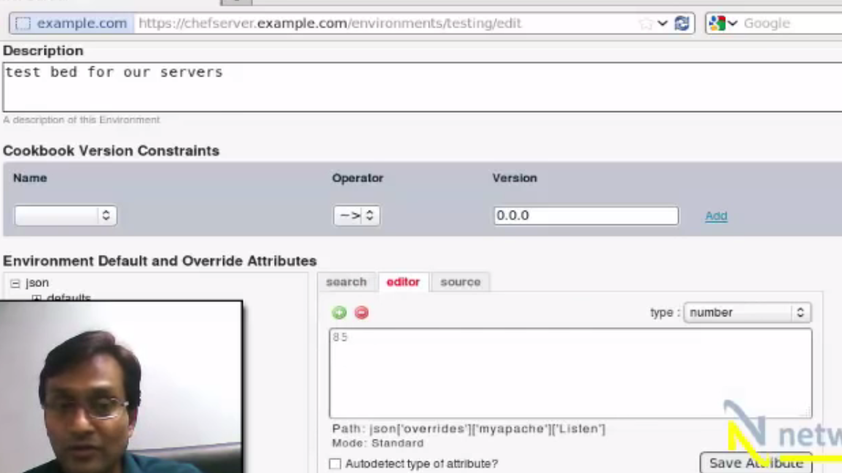

server:

environment ->testing environment ->click on add

nodes --> click on add it -->change the environment to testing.

this is how you change the node from one environment to another environment.

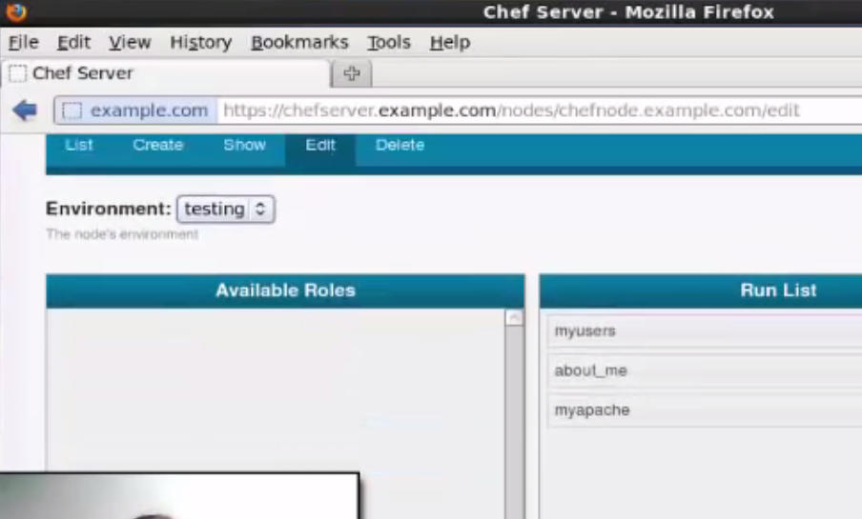

my cookbook is already coming up here in the run list.

I just changed the environment of the node.

the cookbook is same but because it's in a different environment, whatever attributes i was overriding those will be applied or being taken the priority over the attributes which are coming from the cookbook.

before I go to the node, goto /var/chef/cookbooks/myapache/attributes--> default.rb

Cookbook says: apache should run one port number 81, which is in the default environment.

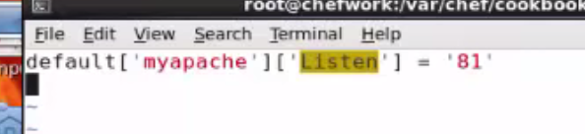

I want that: whenever the machine changes the environment, it should be overridden by 85..which I specified there.

for more interesting, i will change the index.html also.

go to files--> default-->index.html -->like change it i say change it now i am in testing environment.. I change it running on port number 85.

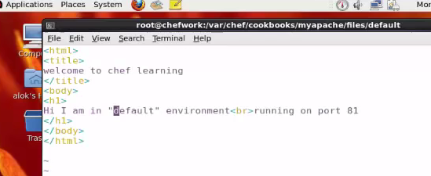

knife cookbook test myapache

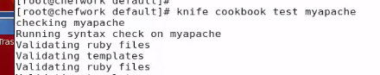

knife cookbook upload myapache

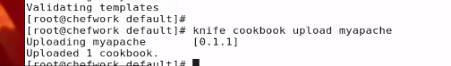

**node:**

chef-client

but this node is now part of the testing environment,and if everything works fine myapache should be running on port number 85.

81 it has been changed to 85 and the contents are also change index.HTML Open the browser--> once again--> refresh --> error obviously because i need to change the port 85

We want apache server, but you cannot run apache on port number 80 in the testing environment because it might conflict with your production server port.

So just create an a dummy environment or any environment, run apache on different port, test it, test your applications.

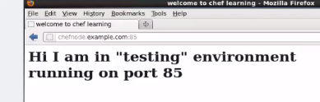

do whatever you want when you are satisfied when you are happy change the environment.